8/10/2026
LAB NO 05
Operating System Lab
Instructor: Ms. Muneeba Banaras
Submitted By: Wasif Ali
Reg ID: 245187
Class: BSCS F’24 B

LAB TASK
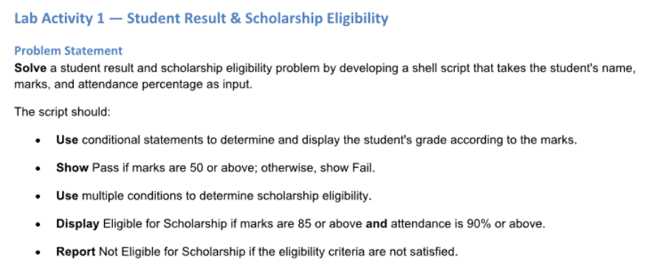

Lab Activity 1: Student Result & Scholarship Eligibility
- The script takes a student's name, marks, and attendance percentage as input.
- It determines whether the student passes (marks of 50 or above) or fails.
- It assigns a letter grade based on the entered marks.
- It evaluates scholarship eligibility, requiring both marks of 85 or above and an attendance rate of 90% or above.

Script File (Shell Script Code):
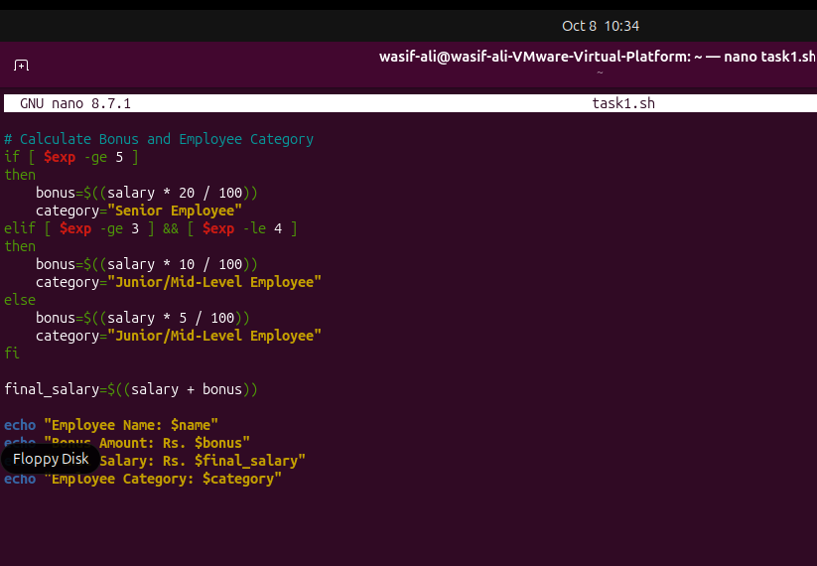
Commands:
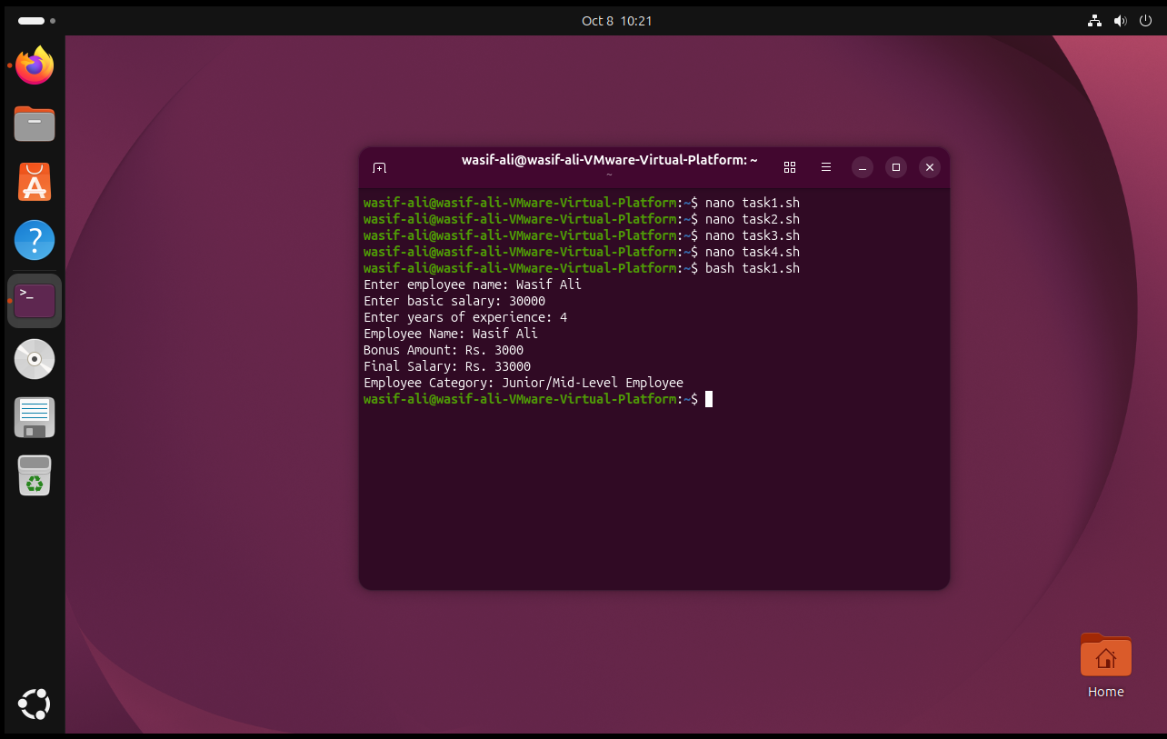

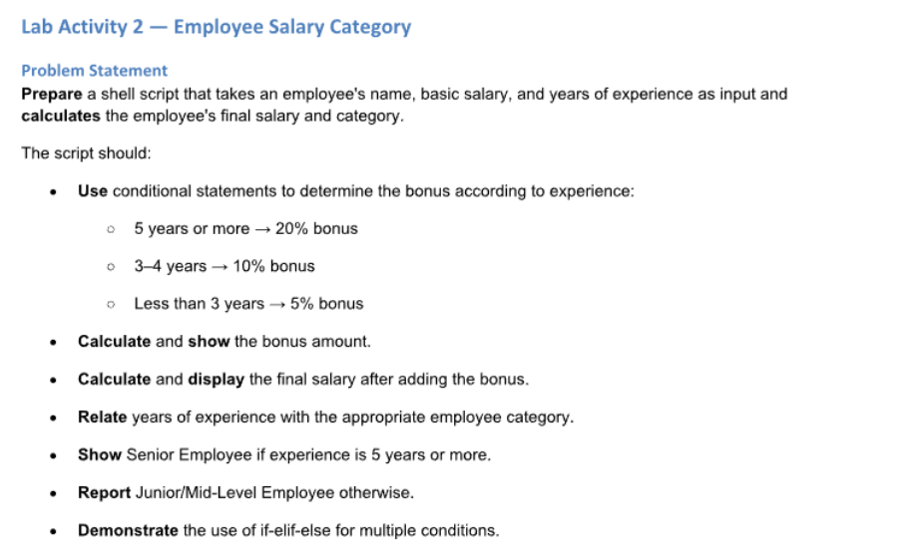
Lab Activity 2: Employee Salary Category
- The script takes an employee's name, basic salary, and years of experience as input.
- It calculates a bonus based on experience tiers: 20% for 5 or more years, 10% for 3 to 4 years, and 5% for less than 3 years.
- It outputs the final salary by adding the calculated bonus to the basic salary.
- It categorizes the employee as a "Senior Employee" (5 or more years of experience) or "Junior/Mid-Level Employee" (under 5 years).

Script File (Shell Script Code):
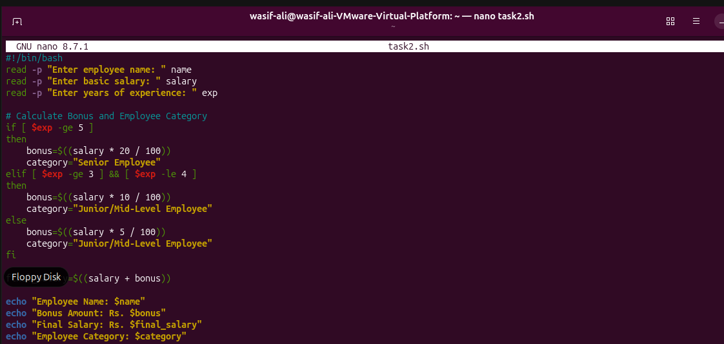
Commands:
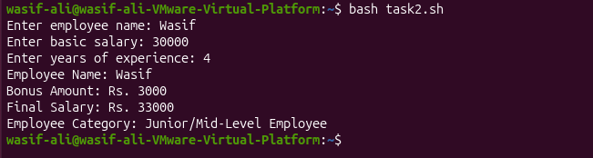

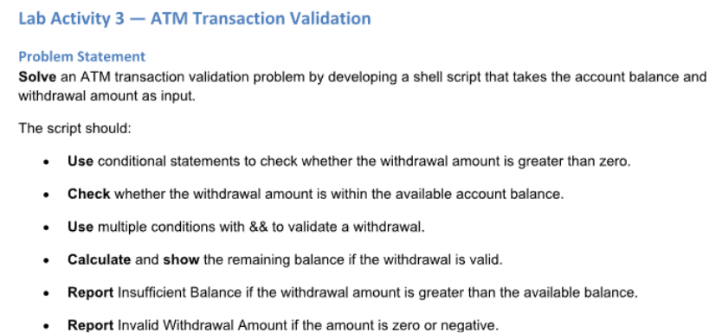
Lab Activity 3: ATM Transaction Validation
- The script takes the current account balance and a requested withdrawal amount as input.
- It validates that the withdrawal amount is greater than zero, rejecting the transaction as an "Invalid Withdrawal Amount" if it is zero or negative.
- It checks that the withdrawal does not exceed the available funds, reporting "Insufficient Balance" if it does.
- It calculates and displays the remaining account balance if the transaction is approved.
Script File (Shell Script Code):
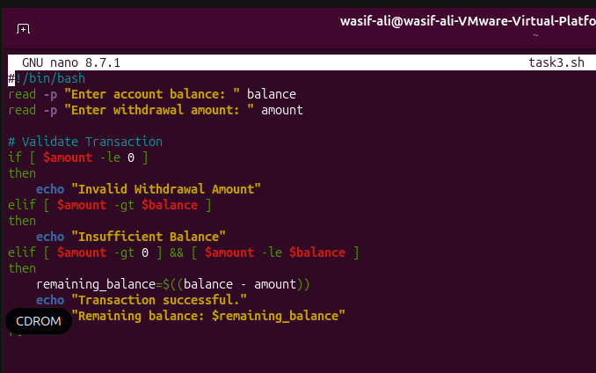
Commands:
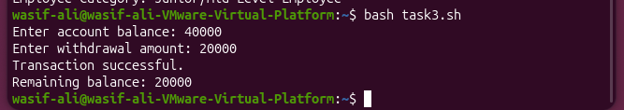

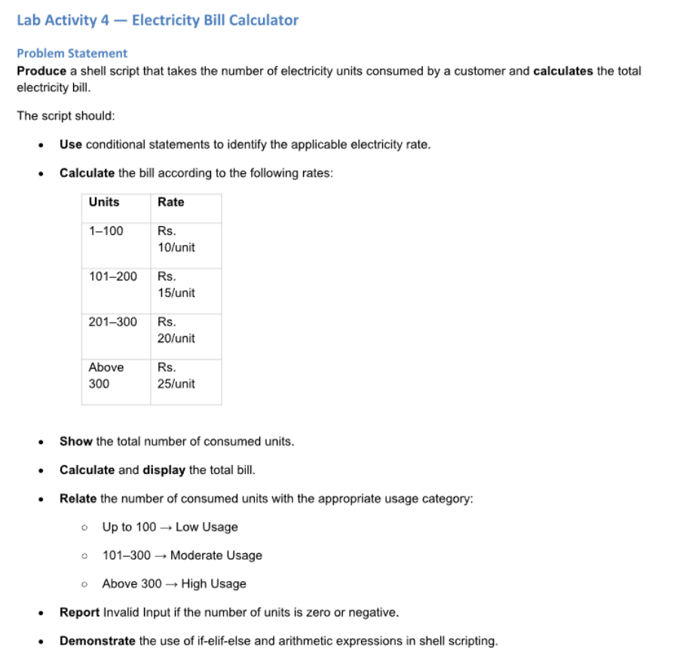
Lab Activity 4: Electricity Bill Calculator
- The script takes the total number of consumed electricity units as input.
- It calculates the total bill based on progressive rates: Rs. 10/unit (1-100 units), Rs. 15/unit (101-200 units), Rs. 20/unit (201-300 units), and Rs. 25/unit (above 300 units).
- It assigns a usage category based on consumption: "Low Usage" (up to 100 units), "Moderate Usage" (101-300 units), or "High Usage" (above 300 units).
- It reports "Invalid Input" if the entered number of units is zero or negative

Script File (Shell Script Code):
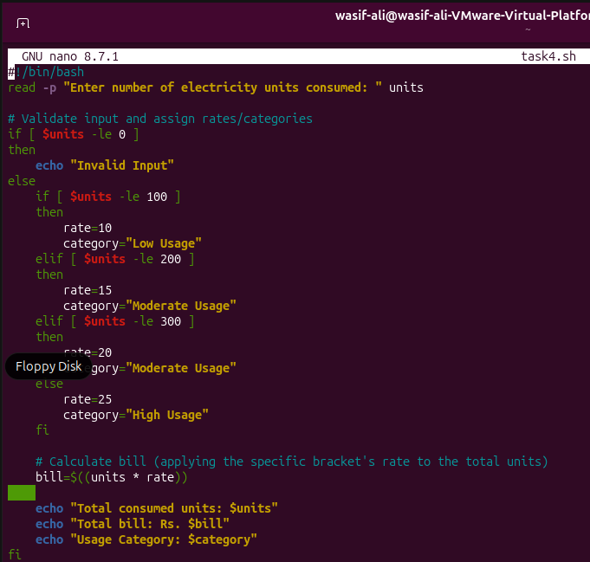
Commands:
